Create Websocket API

Go to AWS console -> API Gateway -> create API

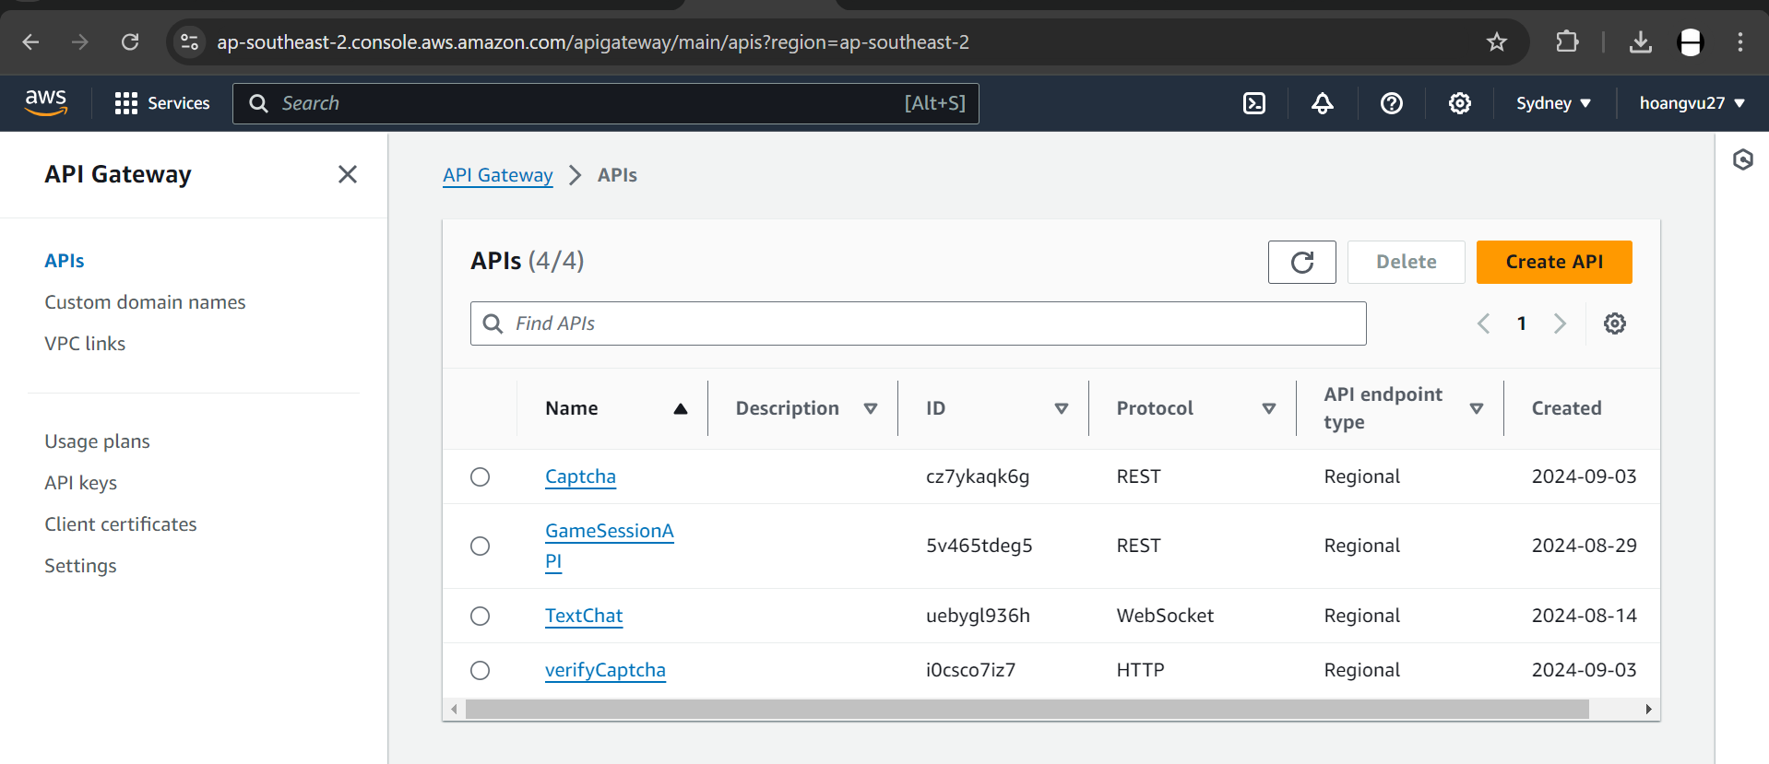

For API name, I chose “TextChat”

For expression, $ request.body.action

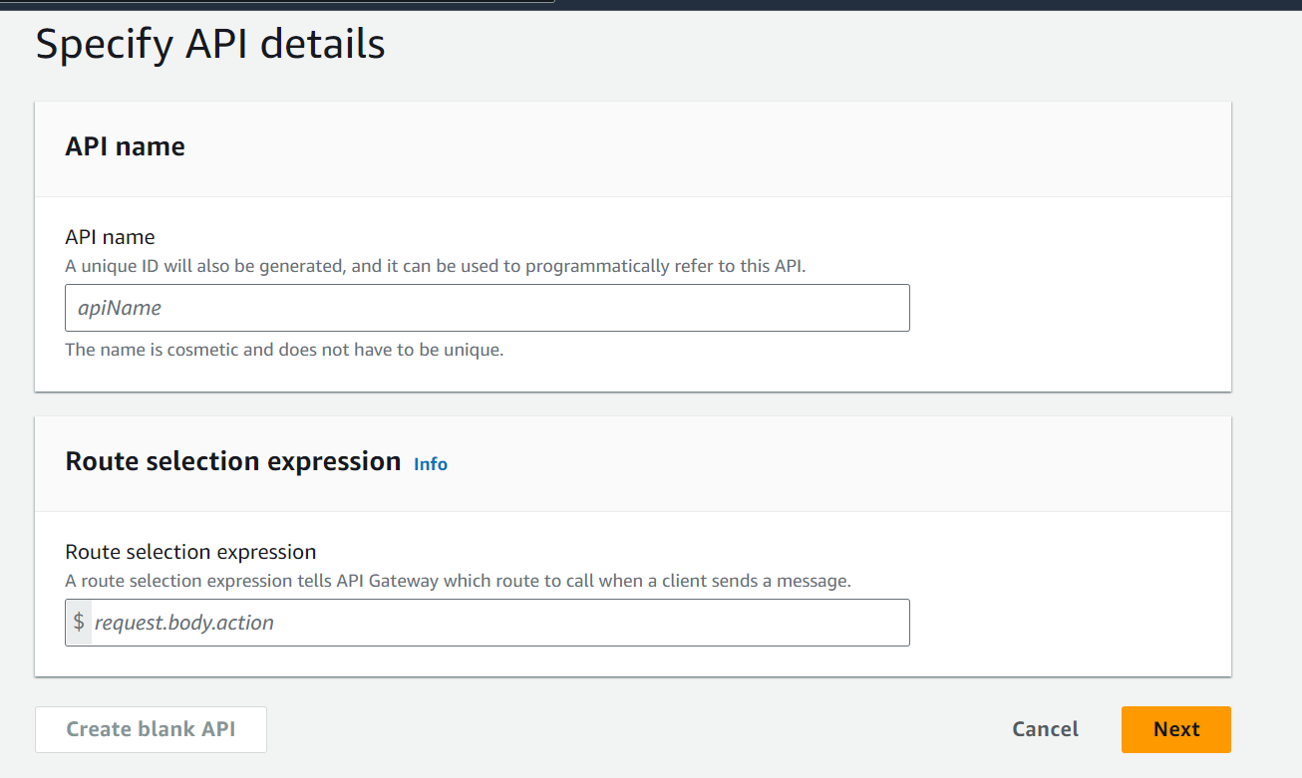

Create route name:

For example, connect , joinLobby, disconnect

Choose type: Lambda function

Connect with lambda_handler function:

For example, connect.py , joinLobby.py, disconnect.py ,

Choose timeout 29000ms

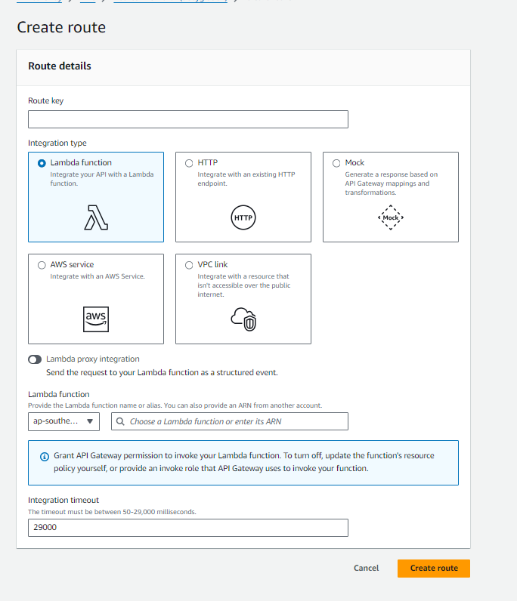

After creation, click “deploy API” button on the top right of API

-> choose stage: either production, deploy, release

2 URLs on the screen will be used for backend connection

